

MORTSCAPE

Domain Competency Training

L1.3: Mortgage Servicing

Version No. 1.1

Version 1.3
Oct 1st, 2005

Cognizant Technology Solutions US Corporation
500, Glenpointe Center West
Teaneck, NJ 07666
www.cognizant.com

Table of Contents

1.0 Loan Servicing Overview 3
2.0 Loan Servicing Processes 4
2.1 Cash Management 5
2.2 Investor Accounting and Reporting 6
2.3 Document Custodianship 7
2.4 Escrow Account Administration 7
2.5 Delinquency Management 8
2.6 Customer Service 8
3.0 Loan Servicing Players 9
3.1 Loan Servicers 9
3.2 Trustee 13
3.3 Paying Agent 13
3.4 Primary Custodian 13
3.5 Primary Collateral Trustee 13

Loan Servicing Overview
Loan servicing (sometimes also referred to a ‘Loan Administration’) refers to the part of the mortgage value chain that starts after the closure of the loan and extends till the loan is fully repaid and settled. It includes activities such as cash management for periodic payments and disbursements, investor accounting, investor reporting, customer servicing, delinquency management, records management etc.
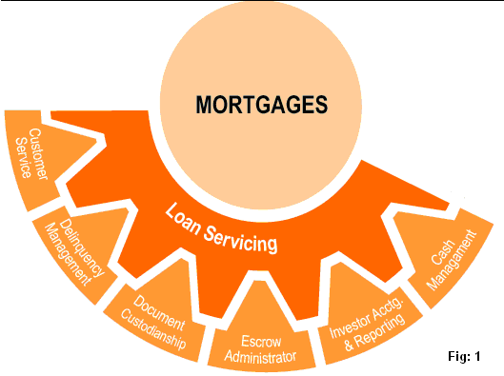
As shown in the schematic above, Loan Servicing involves collecting monthly payments from borrowers, remitting the payments to the investors (or security holders), handling contacts with borrowers about payments & delinquencies, maintaining records, initiating foreclosure procedures and handling taxes and insurance premiums (through escrow accounts as applicable).
The collection of mortgage payments and the periodic remittance of these payments to the investors (or conduits) is the major task of servicers. In addition, servicers are the primary repository of information on the mortgage loans. Thus, they must maintain accurate and up-to date information on mortgage balances, status and history and provide timely reports to investors.
Servicing activities generate a revenue stream of their own that is separate from the revenues generated by the other mortgage banking activities. However, the servicer requires efficient processes and economies of scale in order to realize the full potential of this revenue. This involves huge investments in Information Technology for accounting, disbursements and document management. Hence, the servicing market is dominated by specialists and servicing rights are sold in secondary market (the owner of loan must approve this sale) to entities who specialize in servicing – such entities are called Servicers.
The business model of Servicers is based on operational efficiency, strong internal controls, cost management and compliance to investor requirements. The revenue that is generated in servicing originates primarily from the servicing fees. The servicing fee is an annual fee that is based on the outstanding mortgage balance and is typically in the range of 0.25% to 0.50% of the outstanding loan balance.

Loan Servicing Processes
Once the loan has been closed by the loan originator with the help of closing agents, the loan has to be set up by the servicer in its systems. The loan setup includes creating a loan-id with all the specific details regarding borrower, collateral, originator added to the servicer database. The loan setup also includes taking note of all the financial details (e.g. interest rate, payment period, cash inflow, amortization schedule) regarding the loan. The loan servicing process starts after the loan has been setup in the servicer’s systems.
As shown in the figure 1 in the previous section, servicing can be broken into the following sub-processes / activities:
- Cash management
- Investor accounting and reporting
- Document custodianship
- Escrow account administration
- Delinquency Management
- Customer service

A schematic diagram showing these sub-processes and their interactions is given below:
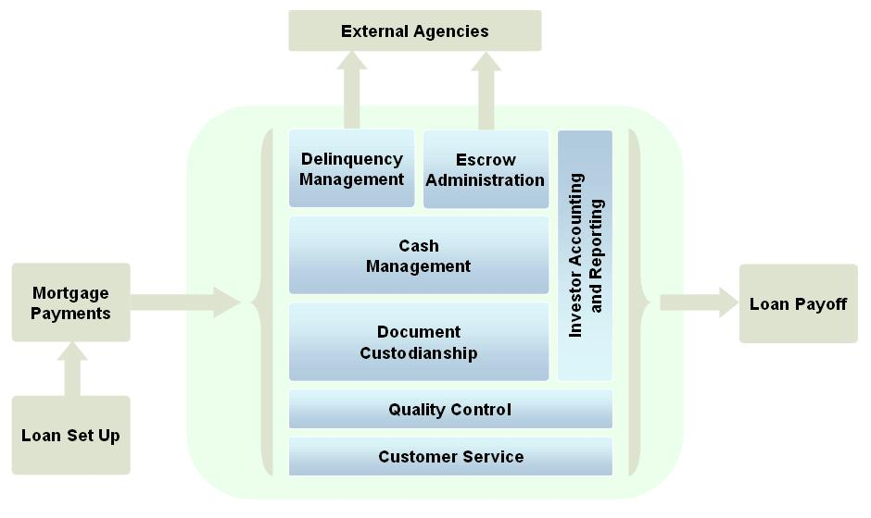
Each of these sub-processes is explained in the sections that follow.

Cash Management
Cash management consists of collecting borrowers’ mortgage payments and depositing those funds into various custodial accounts. The mortgage payment consists of Principal, Interest, Taxes and Insurance (PITI). The principal and interest portion of each payment is separated from the insurance & taxes. The Principal and interest has to be remitted to Investors and insurance and taxes have to be paid out to respective third parties through escrow accounts.

The payments from thousands of borrowers come in at different times with different PITI structures. These payments are used to pay the investors and other parties on predefined regular intervals - for example, taxes may be paid annually, insurance premiums may need to be paid on a monthly basis etc. The servicer keeps a predetermined percentage as its servicing fees.

Due to such mismatches in the timing of cash inflows and outflows, these custodial accounts require daily balancing and monthly reconciliation. In addition to this, prudent procedural control over disbursements, segregation of administrative duties and the deposit of funds into appropriate financial institutions has to be managed. Thus cash management involves managing daily investments, processing of electronic funds transfers, management of servicer-investor relationship and identification & reconciliation of account activity.

Investor Accounting and Reporting
Investor accounting and reporting consists of performing various recordkeeping and customer communication functions on behalf of investors. These responsibilities involve preparing monthly reports on principal and interest collections, delinquency rates, foreclosure actions, property inspections, charge offs, and OREO* for the loan portfolio. Servicers also report information to consumer credit bureaus on the past-due status of a homeowner’s loan. Servicing adjustable-rate mortgage loans requires ensuring that the interest rate adjustments are properly performed and documented, and that customers are notified in accordance with investor guidelines.

To summarize, the main responsibilities of the servicer under Investor Accounting and reporting include:
- Performing quality assurance as per investor specifications
- Verifying bond model calculations
- Coordinating with various third parties like delinquency management agencies, insurance companies, state tax departments and trustees
- Maintaining proper documentation of all transactions
- Providing information such as – loan pool summary, loan level information, delinquency information etc.
- Collection of balances or charging-off uncollectible balances in a timely manner.

Document Custodianship
Under Document Custodianship, the servicer is responsible for ensuring that all the important collateral documents are obtained and released for loan servicer portfolio. These documents include all the reports and documents collected during loan origination. A servicer may perform document custodianship functions on its own or may outsource it to a third party agency.

Escrow Account Administration
An escrow account is a special type of account through which payments can be made only to certain designated parties. In this case the parties are state tax collection agencies and the home insurers. The Tax and Insurance portion of the PITI payment is collected in this account and paid out to various third parties.
The escrow account administration unit sets up the account, credits the account for the tax and insurance funds received as part of the borrower’s monthly mortgage payment, makes timely payments of a borrower’s obligations, analyzes the account balance in relation to anticipated payments annually, and reports the account balance to the borrower annually. If a borrower’s escrow account has a surplus or shortage, the unit makes a lump-sum reimbursement or charge to the borrower, or adjusts the amount of the homeowner’s monthly mortgage payment accordingly.
If there is a change in servicer by sale of servicing rights, it is the old servicer's responsibility to inform the insurance company and tax authority of the change in servicer. A follow-up call from borrower to the insurance company or tax authority can help to ensure that the tax or insurance bill is not sent to the wrong servicer. If the escrow account is interest-bearing, all interest due should be credited to borrower’s account by the old servicer before this transfer takes place. After servicing is transferred, the new servicer analyzes the escrow account again. During this analysis, the servicer reviews escrow amount and determines if it is adequate to cover the fees for insurance, taxes and any other premiums paid through escrow. If the amount is found to be insufficient, the servicer may ask the borrower to increase regular monthly payments.
The escrow account administration responsibilities of the servicer include:
- Collecting and holding borrower funds in escrow to pay real estate taxes, hazard insurance premiums, and property assessments.
- Setting up and continuous review of the escrow account, making timely payments to third parties for taxes and insurance.
- Analyzing the Taxes and Insurance portion of borrower’s account balance and compare it with the anticipated payments annually and reporting the account balance to the borrower annually.

Delinquency Management
If the borrower does not pay the promised monthly payments, reminders are send for a certain period of time after which the borrower is declared to be delinquent as he has defaulted on the loan. Then the servicer performs delinquency management activities to take possession of the home and sell it to recover the outstanding loan amount. Delinquency Management thus refers to default Management, which includes tracking and reporting the status of loans that are in various stages of default. The activities involved in delinquency management are:
- Account review of the delinquent borrower
- Delinquency management reporting to investors
- Foreclosure of the loan which involves actions to eliminate the interest of the borrower in the real estate so as to give lender the title.
- OREO* and REO* marketing – Consists of managing and disclosing foreclosed properties, being involved in repairs and inspection
- Consult with servicers on miscellaneous issues like taxes, delinquency activities, hazard insurance settlements etc.

In some cases a servicer may enter into a short-term forbearance arrangement with a delinquent borrower before beginning a foreclosure action. For example, a servicer may permit the borrower to defer payments, follow an alternative repayment plan, or execute a deed-in-lieu of foreclosure.
A servicer advances funds and incurs costs on behalf of investors during the collection process and during the time foreclosed property is administered as other real estate owned. An account receivable is normally established to account for these investor advances. The investor subsequently reimburses the servicer for much of the funds advanced and costs incurred.

*Real Estate Owned and Other real estate owned (REO & OREO) administration consists of managing and disposing of foreclosed properties. Some mortgage servicing agreements require the servicer to take legal title to OREO. In these cases, the investor transfers property title to the servicer following the foreclosure action. If the bank has or will obtain legal title to the property, management must follow the terms and conditions under which a national bank may hold real estate and other real estate owned, as specified in 12 U.S.C. 29 and 12 CFR 34. When the bank bears primary loss exposure for a serviced loan, management must follow the instructions for preparation of the Report of Condition regarding loan loss recognition and OREO reporting. Servicing agreements may also include provisions involving OREO that merely require the servicer to perform administrative duties as agent for the investor. For example, the servicer may be required to secure and protect the property, conduct inspections on a regular basis, obtain a current appraisal, and market the property.

Customer Service
The loan servicer provides various reporting and information services to the investors. Generally, the loan servicer has a toll free number that borrowers may call for information on such items as loan balances, interest paid, amortization schedules, escrow balances, etc.

Customer Service is also responsible for following activities:
- Create and maintain a positive relationship with borrowers with regular communications on interest rate changes, loan balances, payments etc.
- Customer communication is especially important before and after sale of loan servicing portfolio or during periods of high business activity.

Loan Servicing Players
As discussed in the previous sections, some originators sell the loan servicing rights to firms that specialize in this area so that the originators themselves may focus on origination and leave loan servicing to specialized entities. Some of these specialized entities are firms that are pure loan servicers who purchase pools of loan after origination and manage only the servicing function. Other firms perform this task in varying degrees and at varying geographical coverage. Given the variety of firms involved in Loan Servicing, it is worthwhile to discuss the various players involved in this area.

Loan Servicers
Loan Servicers are specialized players and perform the major servicing functions themselves. This includes ensuring that cash flows reach their appropriate destination (i.e., investors, either directly or by forwarding them to the master servicer or trustee) in a timely manner. The servicer is also responsible for escrow administration and for investor reporting.
When the originator sells loans into the secondary market with a clause allowing it to continue servicing the loans, servicing rights are said to be “retained” by the originator. Because servicing produces revenue, everything else being equal, loans with servicing released sell for more in the secondary market than those where servicing is retained. If the loan is sold in the secondary market with servicing released, Security Issuers can also service the loans in the pool backing their securities, or a third party can be contracted to handle servicing for the issue.
As a result, a mortgage issuance not only includes the details concerning loan characteristics, but also the servicing requirements associated with the underlying mortgages in the pool. Among other elements, these pooling and servicing agreements (P&S) specify when and how servicing can or must be transferred in the event that the servicer falters.

The P&S also specifies the nature of the servicer’s responsibility during default, delinquency and foreclosure. (Industry divides these into “collection”, which are loans less than 30 days past due, a default is a non performance of a contract, more than 30 days past due is called as delinquent) Often the primary servicer will be responsible for managing these processes, trying first to cure the loans though workouts and, potentially, through modifications, and then handling the foreclosure process for loans that cannot be cured. Sometimes these functions are referred to a special servicer who excels at dealing with problem loans. The primary servicer may also be obligated to advance delinquent principal and interest to the investor, even though it is not received from the borrower. For the servicer, compensatory repayment occurs only if the loan cures or when cash flow from one or more sources of credit enhancement is substituted for cash not supplied by the borrower (the nature of the servicer’s ‘advance requirements’ are specified in the P&S). Even though they are later reimbursed, the opportunity cost of the funds advanced prior to repayment usually provides a strong incentive for the servicer to avoid foreclosure. At the same time, however, they imply that once loans are deemed unrecoverable, servicers should foreclose quickly to minimize losses.

The P&S typically also specifies a “master servicer”, whose function is to protect the interests of investors by overseeing the actions of the primary servicers and any others involved in the issue and by ensuring timely remittance of funds. Under normal circumstances the master servicer’s duties are modest and involve compensation on the order of approximately eight basis points in the prime market (whereas primary servicing in the Subprime market typically is on the order of 50 basis points approx.). In cases where the primary servicer becomes unable to perform its duties, however, the master servicer will be responsible for collecting principal and interest and ensuring that they are transferred to the appropriate parties in a timely manner, either by performing the primary servicer role themselves or by ensuring the transition to a ‘back-up servicer.’ Depending on the specifics of the P&S, the master servicer may also be required to advance principal and interest to the trustee or investors in the event that they are not forthcoming from borrowers.

A third class of servicer is the “special servicer” who is responsible for working the more difficult, often nonperforming loans, first-payment delinquencies, and/or handling the Real Estate Owned (REO) process. Special servicer compensation typically reflects the challenges of these more difficult loans. A special servicing contract might stipulate bonuses for loans in foreclosure proceedings that the servicer returns to normal cash flowing loan or to fully cured status, and penalties for underperformance. The special servicer puts in best efforts to bring the loans back to normal cash flow status. Sometimes, if the borrower has recently lost a job or another source of income, the lender might be willing to temporarily reduce or suspend the payments. This option of ‘Foreclosure’ is called Special Forbearance.

A final wrinkle in the servicing nomenclature is the sub-servicer. These participants perform much of the primary servicer’s role on a fee basis, but do not actually own the servicing rights. Sub-servicing and servicing are not mutually exclusive business lines and many servicers on both the prime and Subprime side do both. A sub-servicer for example may specialize in document management and perform all or some of the Document Custodianship functions for the Primary Servicer.

A primary mortgage servicer’s activities and relationships with other servicers are shown in the diagram below:

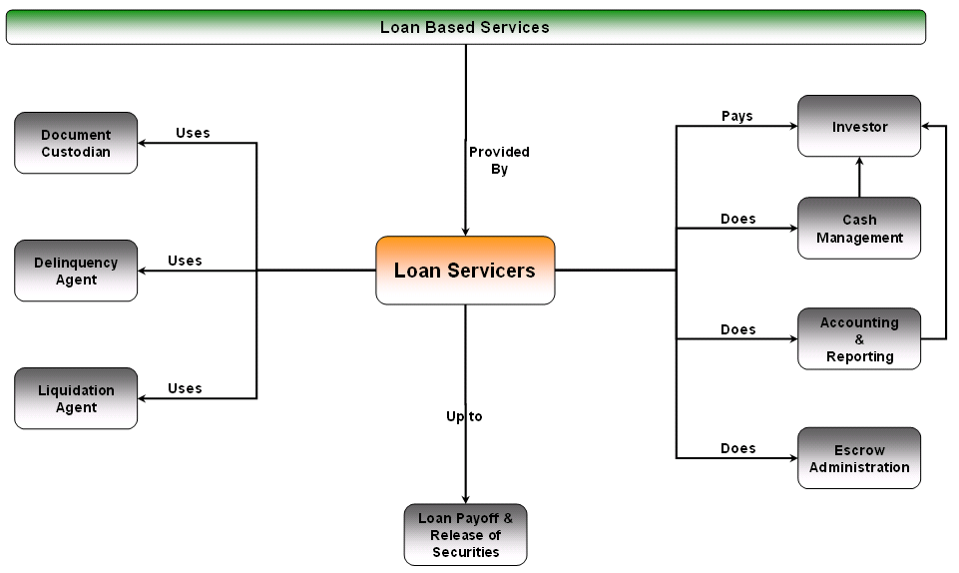
To summarize, the loan servicing players can be segmented into three categories depending on the roles they play in servicing of mortgage loans. These players have been briefly elaborated below.
Master Servicer
- Assumes ultimate responsibility for administration of all mortgage loans contained in a commercial mortgage securitization
- Handles all reporting and remittance as required by the particular pooling and servicing agreement with the client
- Makes remittances to the client or trustee, plus periodic reports to the trustee and rating agency
- Assures diligent loan payment collection and administration by each primary/sub-servicer, regardless of:
  - Relationship with the mortgagor.
  - Ownership of any certificates.
  - Obligation to make advances.
  - Compensation or cost reimbursement.
Primary Servicer
- Provides monthly billing statements to borrowers
  - Timely collection and application of payments.
  - Escrow administration.
  - Financial statement analysis.
  - Property inspections.
- Prepares and provides periodic reports and remittances to the certificate holder or master servicer.
- Performs all tasks and obligations required by the servicing agreement with the certificate holder or master servicer.
Special Servicer
The special servicer:
- Assumes responsibility for administration of a mortgage loan after a servicing transfer event occurs, such as:
  - A balloon payment on a mortgage loan becomes 30 days past due.
  - Regular monthly payments or other required payments remain unpaid for at least 60 days.
  - A default occurs that materially impairs the value of the mortgaged property and adversely affects the interests of the certificate holders.
  - The mortgagor is declared bankrupt or insolvent, or consents to the appointment of a conservator, receiver or liquidator.
  - The mortgagor admits in writing an inability to pay debts.
  - The master servicer receives notice of foreclosure or similar proceedings.
- Develops and executes effective workout plans for loan repayment.
- Transfers loan administration back to the primary server if the situation is positively resolved and stays so for a certain period of time.

Trustee
The trustee provides oversight of the deal between Loan originator and secondary market investor, managing the payments of cash to investors. The trustee often also acts as the Paying Agent and Custodian for loan documents for the deal.

Paying Agent
The paying agent distributes cash bond payments to investors on a monthly basis. The master servicer/primary servicer deposits cash into dedicated certificate accounts, opened by the paying agents, and the paying agents distribute the cash to individual investors based on the reported distribution amounts provided by client's Bond Admin department.

Primary Custodian
There is usually a main custodian that holds loan documents in trust on behalf of investors in a public security deal. There may be more than one custodian for deals.

Primary Collateral Trustee
There is usually a main Collateral Trustee that has signing authority on behalf of investors in a public security deal. There may be more than one Collateral Trustee for deals, as Collateral Trustee is assigned at the loan-level.

